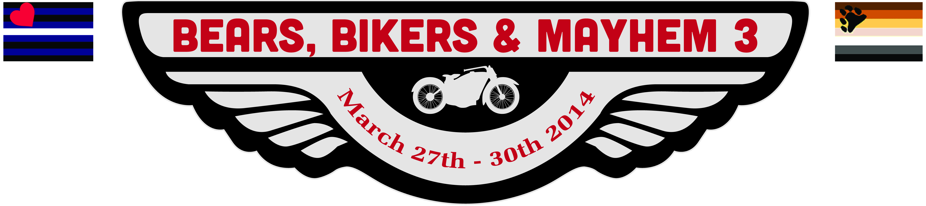

Vendor Registration
Bears, Bikers & Mayhem 2014 Vendor Registration
Hosted by the Susquehanna Valley Bears, The Pennsmen,
and The Capital City Bears

Date: Friday, March 28, 2014: set up after 10:00am, Market Open 4:00PM – 12:00AM.
Saturday, March 29, 2014: Market Open 10:00AM – 5:00PM.
Location: Eisenhower Hotel & Conference Center, Eisenhower I - Ballroom.
2634 Emmitsburg Road, Gettysburg, Pennsylvania 17325

Vendors are required to make a donation of $50.00 per space.10’x10’.
Fee includes one table. Additional tables available at $5 per table.
Add $15 for electric.

Business Name:___________________________________________________
Business type or brief description of goods: ______________________________
_________________________________________________________________
Representative’s Name: _____________________________________________
Address: _________________________________________________________
Phone: ______________________Email: _______________________________
Cost: $50.00 + $15.00 for electric, if needed. ___(check if electric is needed).
Number of additional tables ________ @5.00 = ___________
Total Fee _____________
Payment: (Circle one) Check Cash Credit Card
Name on Credit Card: _______________________________________________
Credit Card #: _____________________________________________________
Expiration Date: _____________________

Email All Applications to: CharlesKingPA@gmail.com, or Fax to: 717-337-3298
Make checks payable to The Black & White Party and mail to:
Charles King
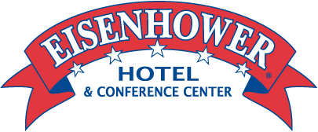
9600 Groveton Circle, C-313
2634 Emmitsburg Road, Gettysburg, PA 17325 717-334-8121 1-800-776-8349 Fax 717-334-6066
Http://www.eisenhower.com

Owings Mills, MD 21117

